1. create a customer table to store following columns, customer id as primary key

customer id, name, mobile set<int>,email tuple(text,text),purchaseveh

map<text,int>,hoobies list<text>

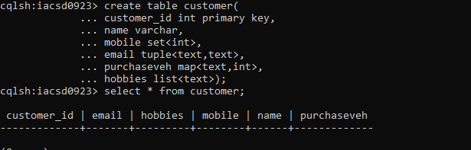

2. insert 5 records with customer id 11,12,13,14,15

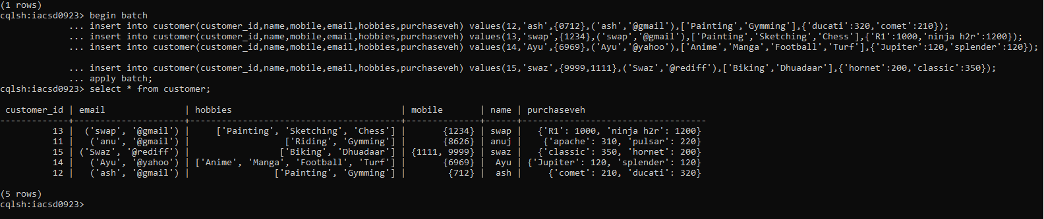

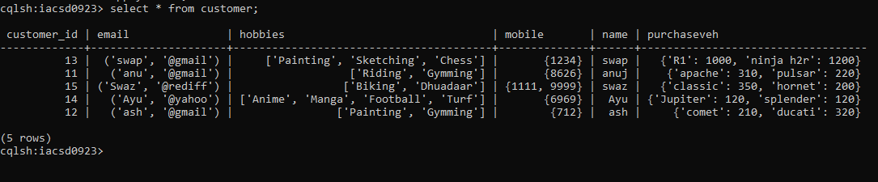

3. add hoobies design, drawing for custid=12

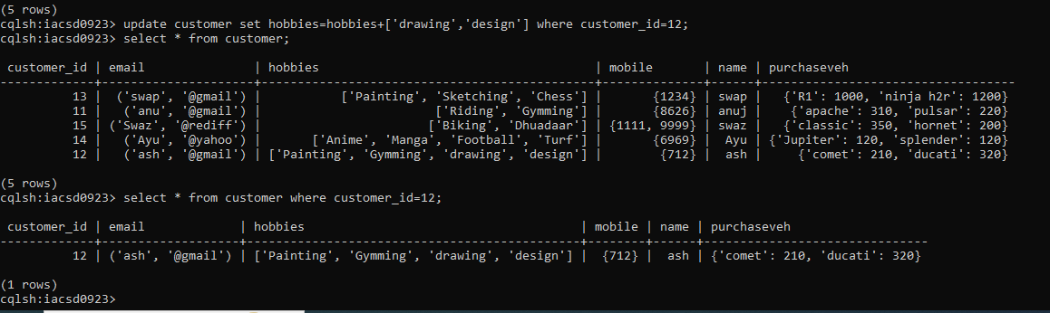

4. remove hoobies design for custid=12

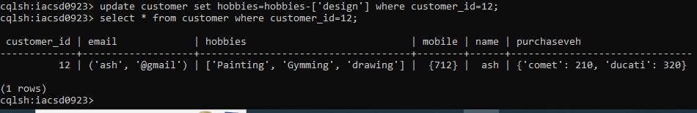

5. update name of customer with id 11

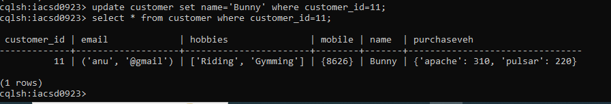

6. modify emails of customer 13

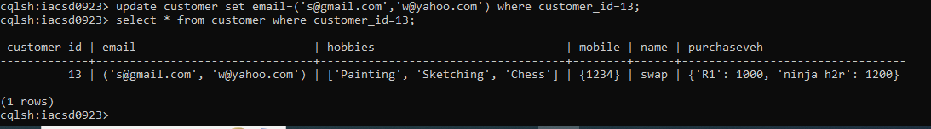

7. add and delete one of the purchase vehicle

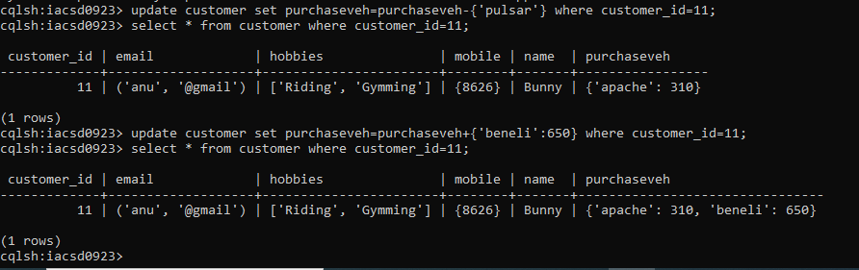

8. add and delete one of the hobbies for customer 14

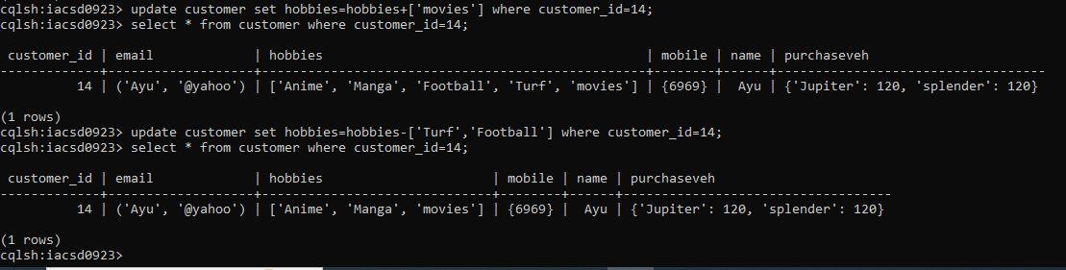

9.change the quantity of vehicle activa from customer id 15

Let us assume vehicle as hornet instead of active:

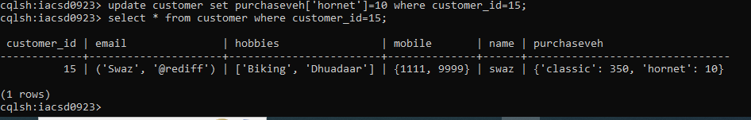

Q2create a batch to add 2 records in customer table, delete record for customer 13

and delete only email from customer 11

and update emails for customer 12

begin batch

... insert into customer(customer_id,email,hobbies,mobile,name,purchaseveh) values(16,('k@gmail','kalp@rediff'),['Reading','photography'],{1356,9876},'Kalp',{'Shine':1,'Vespa':1});

... insert into customer(customer_id,email,hobbies,mobile,name,purchaseveh) values(17,('adi@gmail','mor@rediff'),['helping','playing'],{1356,9876},'Mor',{'Shine':2,'unicorn':1});

... delete email from customer where customer_id=11;

... update customer set email=('ash17','@yahoo') where customer_id=12;

... apply batch;

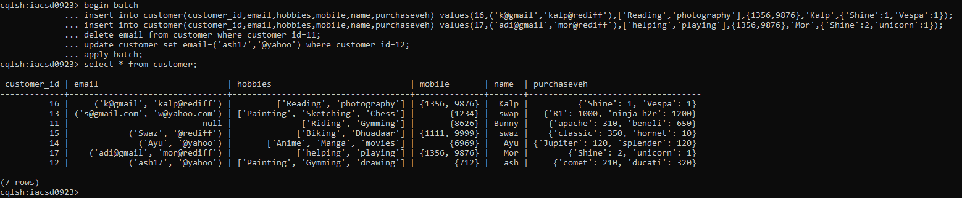

Q3. create type department to store deptno, dname

a. change the type department to add dloc in it.

create table emp to store eid, ename, sal, projects List<text>, dept department

add 5 records in the table

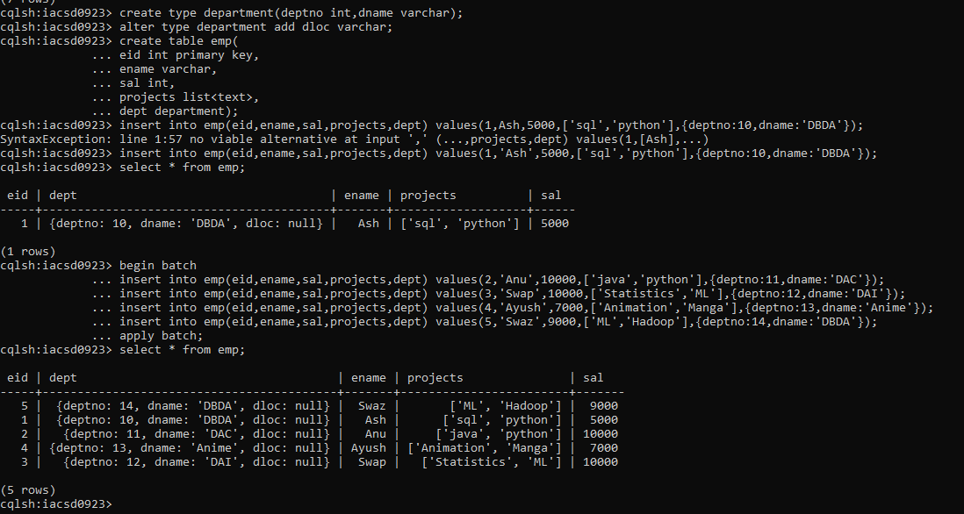

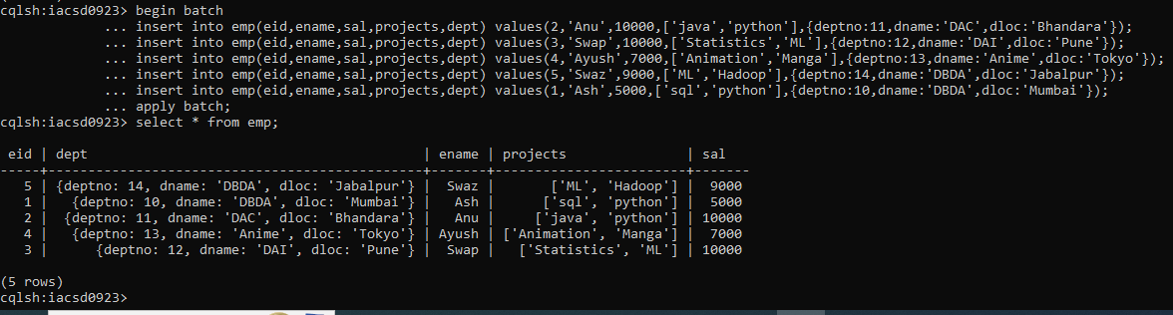

b.

create index on ename column

